**Recovery Scenarios in UFT**

What are Recovery Scenarios?

While executing your scripts you may get some UNEXPECTED/UNPREDICTABLE errors. (like printer out of paper). To “recover” the test (and continue running) from these unexpected errors you use Recovery Scenarios.

When to use “on error resume next” or programmatic handling of errors VS Recovery Scenarios ?

If you can predict that a certain event may happen at a specific point in your test or component, it is recommended to handle that event directly within your test or component by adding steps such as If statements or optional steps or “on error resume next”, rather than depending on a recovery scenario. Using Recovery Scenarios may result in unusually slow performance of your tests. They are designed to handle a more generic set of unpredictable events which CANNOT be handled programmatically.

For Example:

A recovery scenario can handle a printer error by clicking the default button in the Printer Error message box.

You cannot handle this error directly in your test or component, since you cannot know at what point the network will return the printer error. You could try to handle this event in your test or component by adding an If statement immediately after the step that sent a file to the printer, but if the network takes time to return the printer error, your test or component may have progressed several steps before the error is displayed. Therefore, for this type of event, only a recovery scenario can handle it.

The Recovery Scenario Manager presents a structured wizard which helps us in defining the recovery scenario, like detailed definition of the unexpected event and the operations required to recover from the exception during the run session.

Advantages of Recovery Scenario Manager: Recovery Scenario Manager can be used to handle several known errors occurring at runtime. Following four events available in the recovery scenario manager are extremely helpful

1) Application Crash: This event is useful in handling crashed applications at runtime.

2) Pop Up Window: This event is useful in managing various unwanted application windows, which get built-up at runtime.

3) Test Run Error: This event is useful in handling VBScript statement errors at runtime.

4) Object State: This event is useful in handling object related errors at runtime.

Elements of Recovery Scenario: Steps to handle the exceptions are

1) Trigger Event: Is an unexpected event like appearance of a Pop-up window, object state, test run error causing application crash or interruption in our running session.

2) Recovery Steps: Constitutes a series of steps required to be performed to enable QTP to proceed further with the process of test after some trigger event has interrupted the run session. Examples of a recovery operation can be 1) A keyboard or mouse Operation like a Click over the “OK” button in the Pop-up window 2) Close Application Process 3) Function Call 4) Restarting the OS etc.

3) Post-Recovery Test Run: Are a set of instructions designed to be provided to QTP on proceeding further with the test after some recovery operation has been carried out. Examples of Post Recovery actions can be repeating the complete test from the beginning or some steps may be skipped altogether & continuing with the remaining steps in the test.

**UFT & Recovery Scenarios:**

All Recovery scenarios get saved & logically grouped in recovery scenario files. Grouping of various recovery scenarios in recovery scenario file can be managed according the user requirements. Recovery scenario files carry a typical extension of .rs.

In order to instruct UFT to carry out a recovery scenario during a particular test run, we firstly associate it with the particular test. There is no limitation to any fixed number of recovery scenarios associated with a test. Order of execution of various recovery scenarios associated with a test can easily be prioritized, thereby the trigger events get recognized and handled in the desired sequence.

Whenever any error comes during the execution of a test having many recovery scenarios associated with it; UFT intelligently hunts for the defined trigger event which had caused the particular error. After detecting the trigger event, UFT automatically performs the desired recovery steps and post-recovery test runs etc.

Recovery statements can be inserted in the tests to comfortably control and activate the recovery scenarios during the test run.

Cons of Recovery Scenarios:

Although Recovery Scenarios are users friendly on one hand; they tend to slow down the speed of the Test Run. Presence of a few such recovery scenarios would reduce the speed of Test Run significantly. This can become irritant to the testers, who can prefer the approach of using VBScript On Error/Goto 0 far more useful for catching & handling small errors.

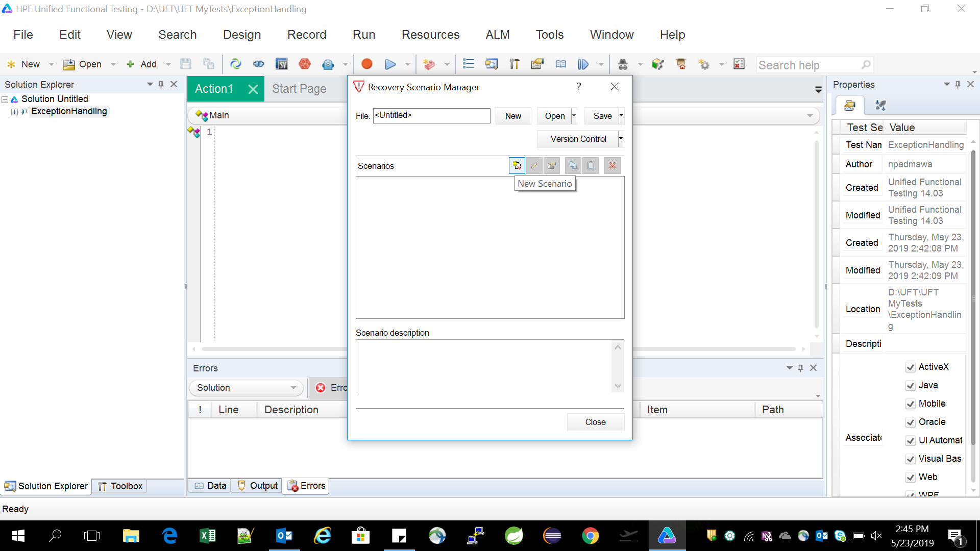

Click on New Scenario icon. Each of the below four points are important to explain

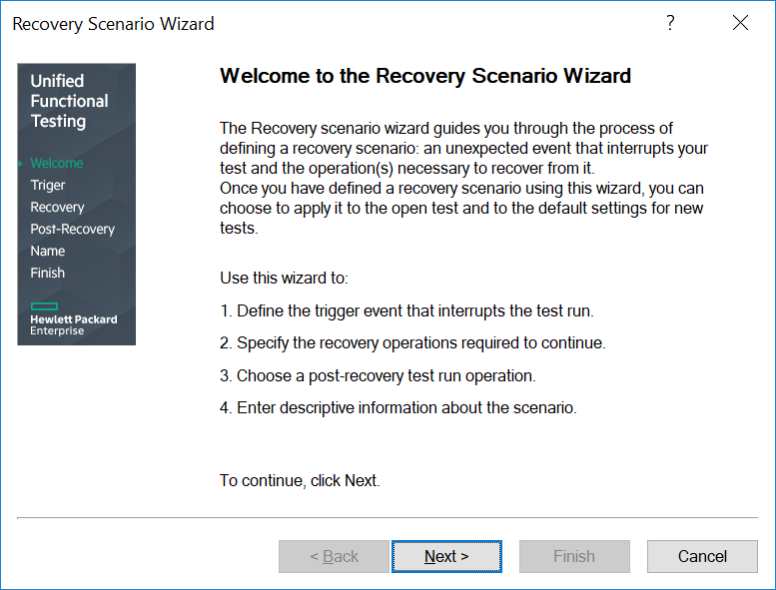

Click on ‘Next. Understand all the below four types of Trigger Events.

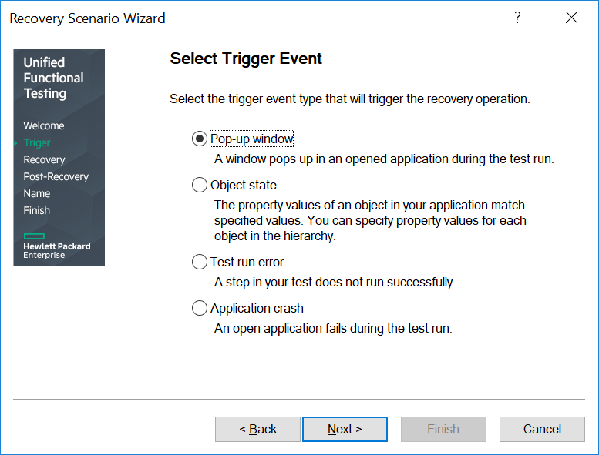

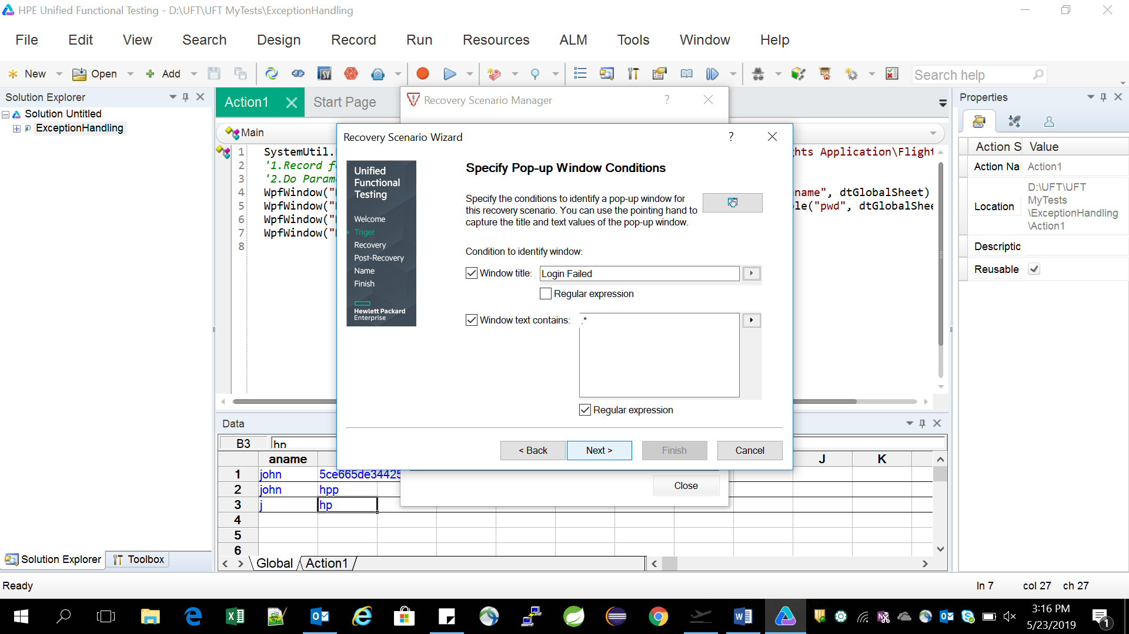

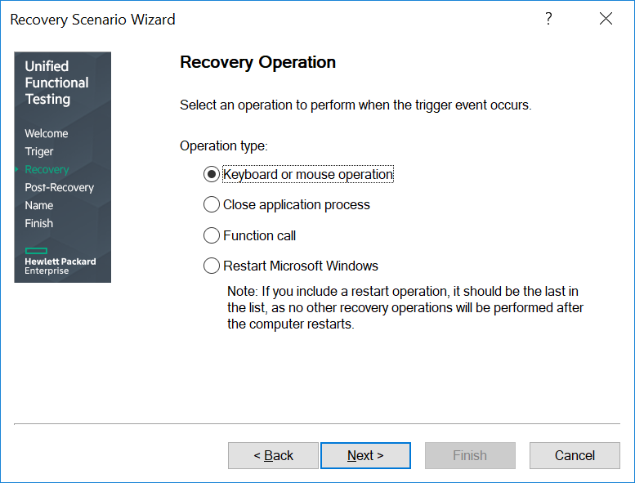

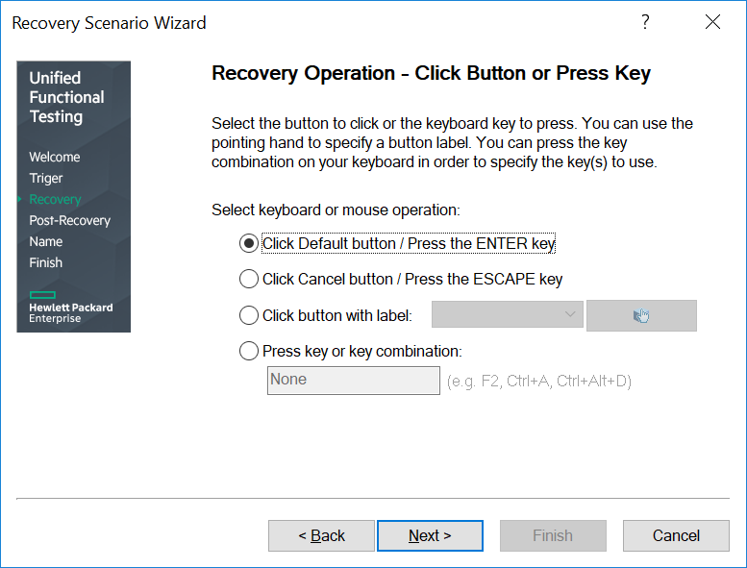

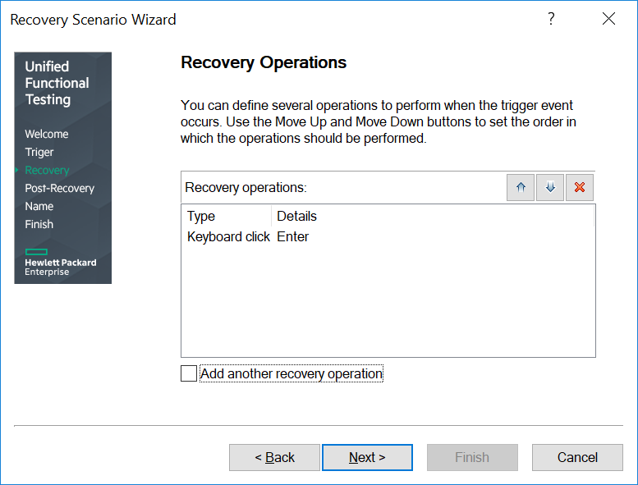

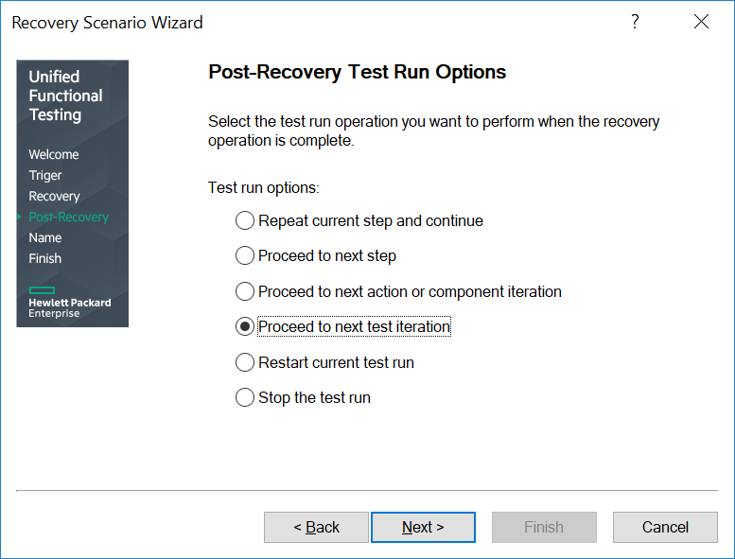

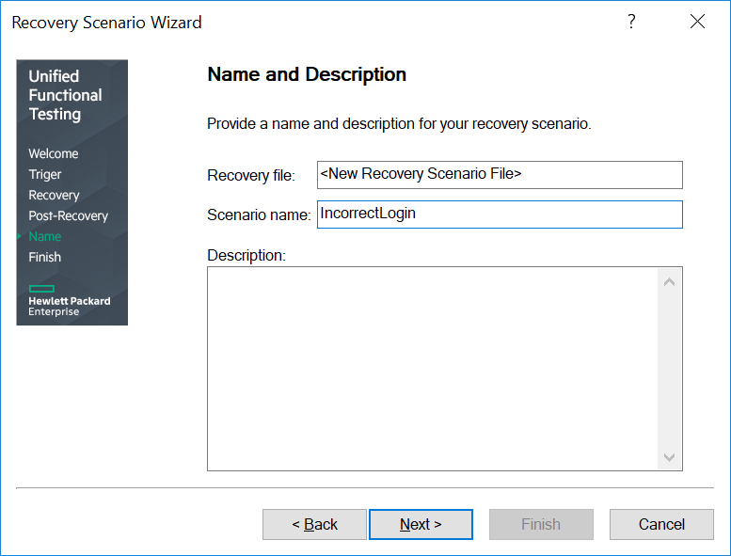

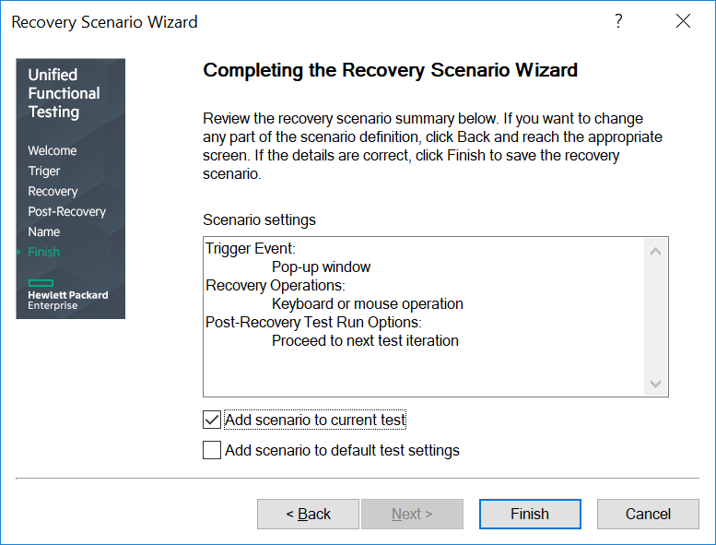

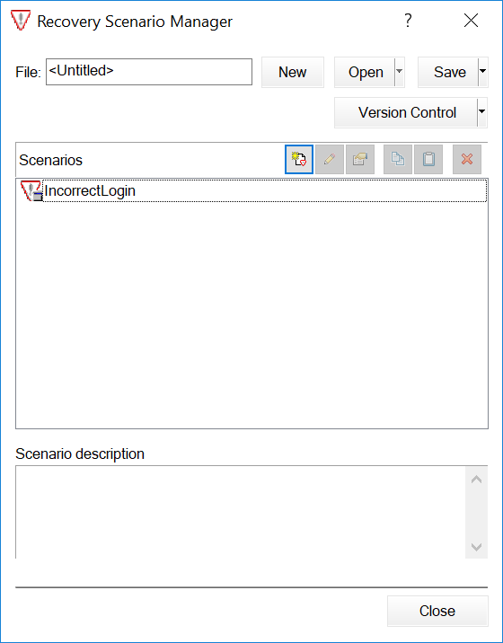

Save it as below :

